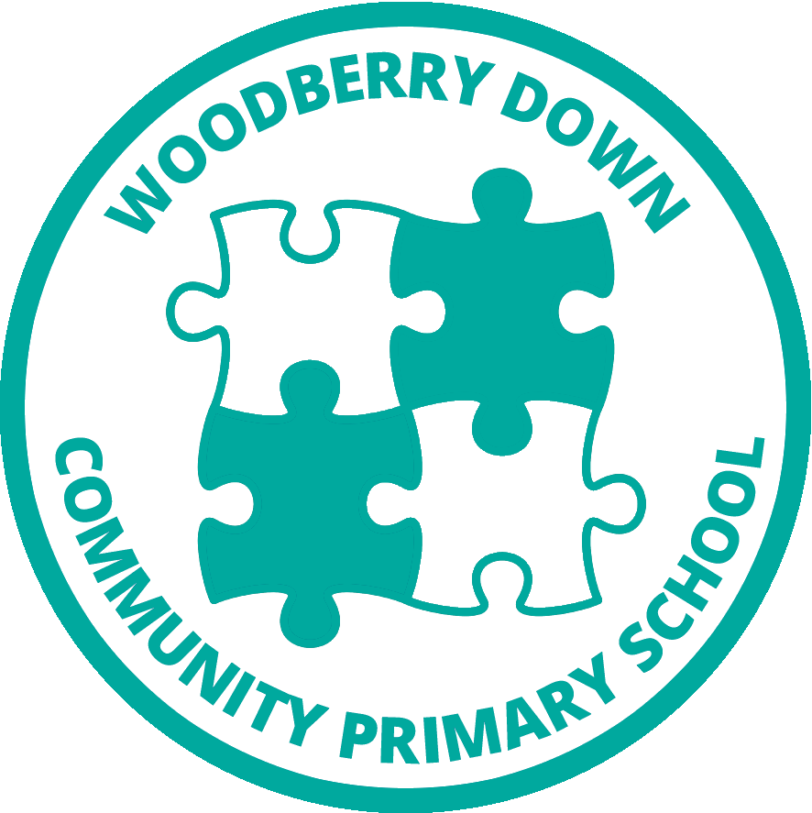

Woodberry Down Community Primary School
Woodberry Grove, London N4 1SY
Telephone: 0208 800 5758

WDoffice@newwavefederation.co.uk
Executive Headteacher: Ms Nicole Reid
Headteacher: Mr Derek Hewie

Friday 5th November 2021
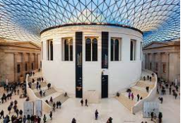
Dear Year 4 families,
We are going on an adventure! How exciting! Here are the details of our outing.
WHO | 4W, 4B & 4D
WHEN | 4W - Wednesday 24th November  4B - Thursday 25th November  4D - Friday 26th November  We will be leaving school promptly at 9am and returning by 3.00pm
WHERE | The British Museum, Great Russell Street, LONDON WC1B 3DG
WHY | To explore the Roman Empire in order to support our in class study.
HOW | We will be travelling on public transport taking the Piccadilly Line from Manor House Underground Station to Russell Square, followed by a short walk. Please ensure your child wears their full uniform, comfortable walking shoes and a waterproof jacket.
CONTRIBUTION | This trip is free.
Packed Lunch | Children will need a packed lunch. Our kitchen can provide children who are entitled to a free school meal with a packed lunch, just let us know on the slip below. Children will need to bring a drink but no glass bottles, fizzy drinks or sweets please. Please be mindful of our children with allergies, no nuts or sesame products please- let’s keep our children safe!.

ALL CHILDREN WILL NEED TO HAVE A PERMISSION SLIP SIGNED
Please ensure that all medication is in school, as your child will need to bring it along.
Finally, would you please sign the slip below and return it as soon as possible.
Many thanks,
Year 4 Classteachers
I* do / do not give permission for my child…………...……..... in Class.................. to join Exploring the Roman Empire trip on 24th November 4W, 25th November 4B & 26th November 4D to the British Museum.
My child is entitled and *will/will not need a packed lunch (please circle one option).
My child will need to take the following medication along with them…………………….........
Signed…………………………….Date………………………

